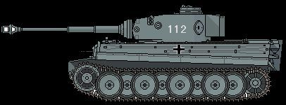
Figure 1Panzer leher
21st Pz
+1

